Project Design Phase
Solution Architecture

Date | 19 February 2026
Team ID | LTVIP2026TMIDS62378
Project Name | Flavour Fusion: AI-Driven Recipe Blogging
Maximum Marks | 4 Marks

Solution Architecture
Solution architecture is a structured approach that bridges the gap between business requirements and technical implementation. In the Flavour Fusion project, the solution architecture defines how user needs for automated recipe blogging are transformed into a scalable, AI-driven software system.
The primary goal of the solution architecture is to identify the most effective technology stack to solve the problem of time-consuming and repetitive recipe content creation. It clearly outlines the structure, components, and interaction flow of the application so that all stakeholders can understand how the system operates.
The architecture describes the behavior of the system from user input to AI-generated output, including frontend interaction, backend processing, and integration with generative AI services. It also defines functional components such as user interface handling, prompt generation, AI communication, content rendering, and logging mechanisms.
Additionally, the solution architecture helps in defining development phases, system features, and technical requirements. It provides clear specifications that guide development, testing, deployment, and future enhancements, ensuring that the solution is reliable, maintainable, and scalable.
Overall, the solution architecture for Flavour Fusion ensures that business objectives—such as fast content generation, customization, and user engagement—are effectively achieved using modern cloud-based and AI-driven technologies.

Solution Architecture Diagram:
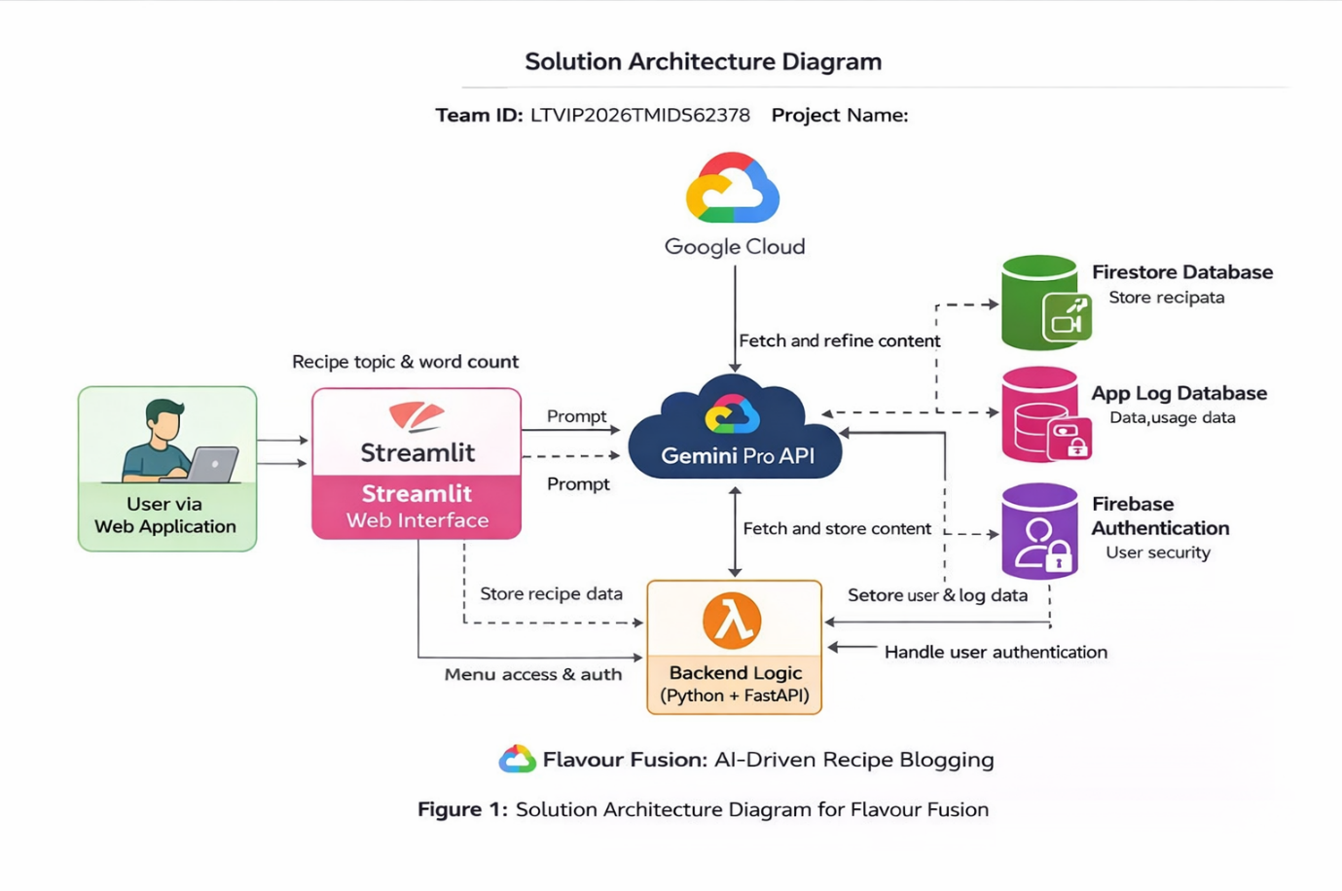

Figure 1: Architecture and data flow of the Flavour Fusion solution architecture diagram
Reference: https://aws.amazon.com/blogs/industries/voice-applications-in-clinical-research-powered-by-ai-on-aws-part-1-architecture-and-design-considerations/

